- Import the dataset into Power BI using Power Query Editor.
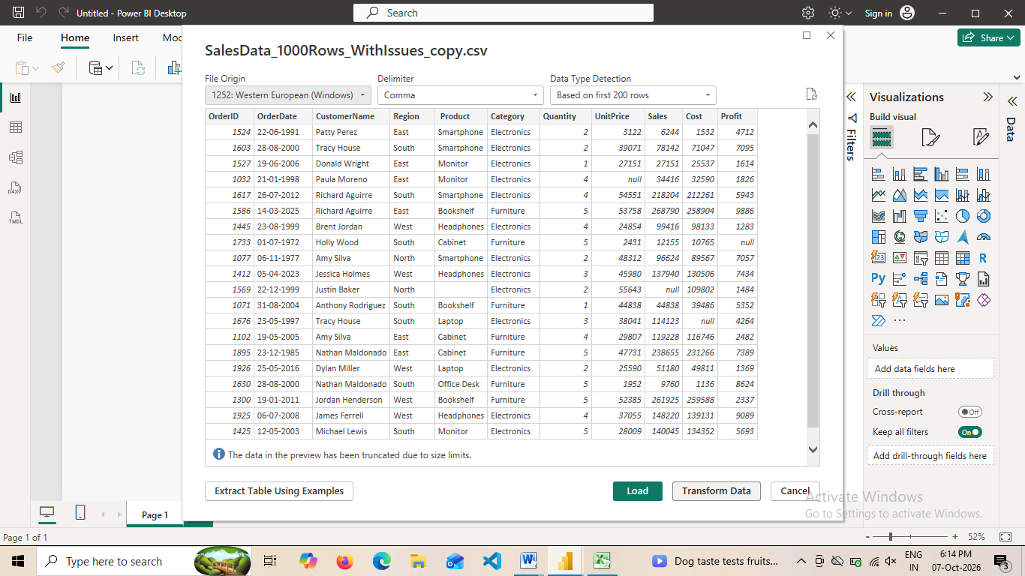
- i) Handling missing values in columns.
impute a standardized historical placeholder date (e.g., 01-01-1900)
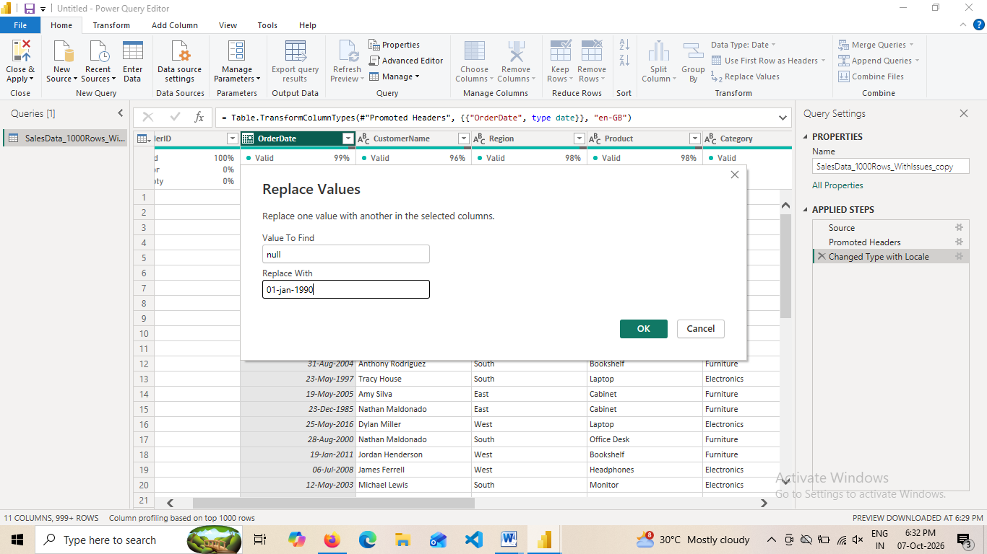
- Missing Values in Region and CustomerName ,Product is Imputed by replaceing with “Unknown”

- if[UnitPrice]=null then [Sales]/[Quantity] else [UnitPrice]
- if[Sales]=null then [UnitPrice]*[Quantity] else [Sales]
- if [Cost]=null then [Profit]-[Sales] else [Cost]
- if [Profit]=null then [Sales]-[Cost] else [Profit]

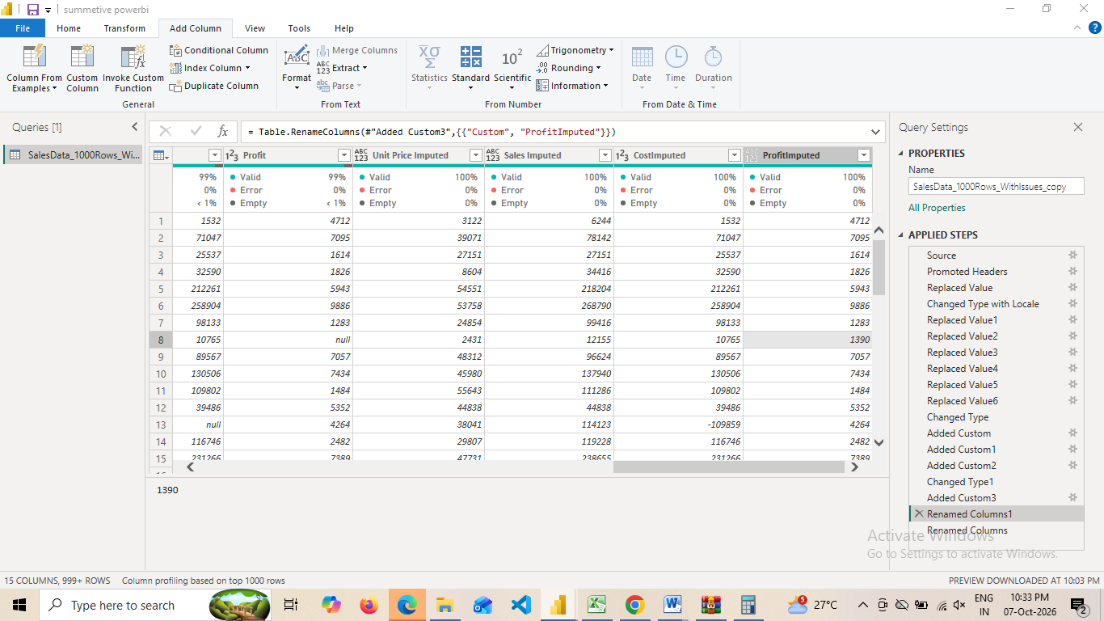
ii) Removing duplicate rows
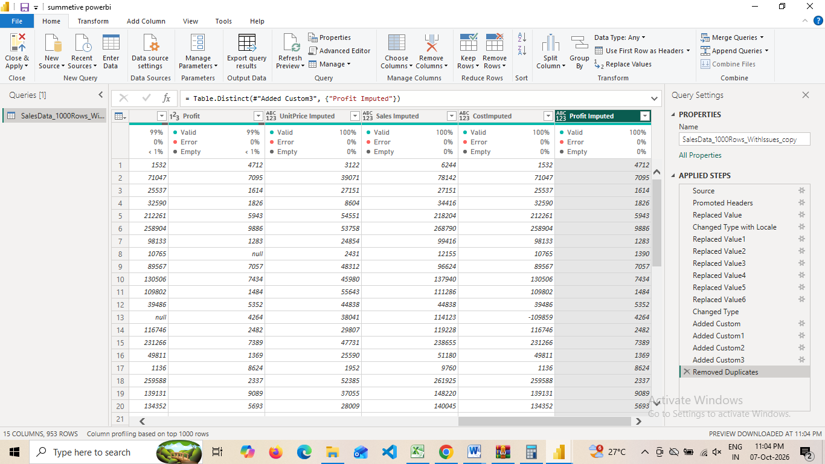
iii) Standardizing the OrderDate column to a consistent date format.
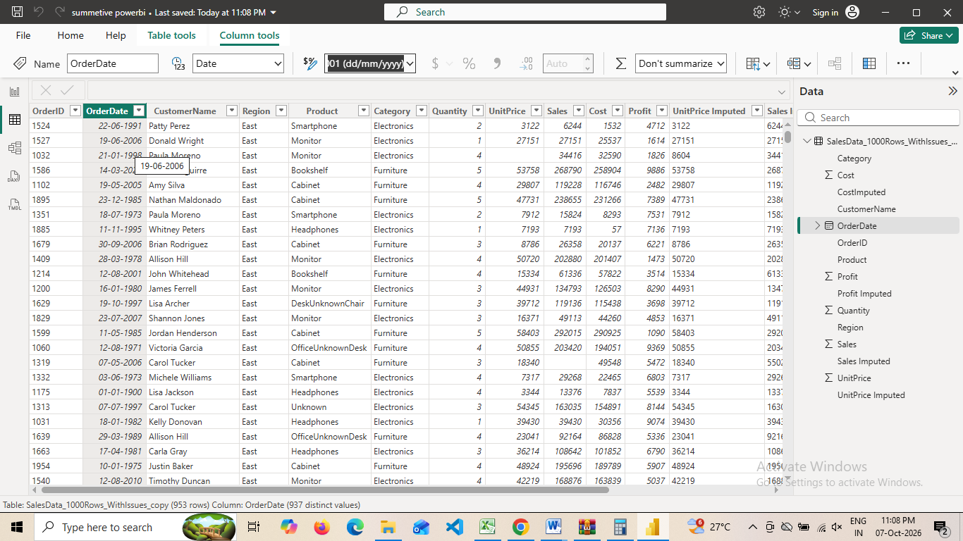
- Load the cleaned dataset into the Power BI model
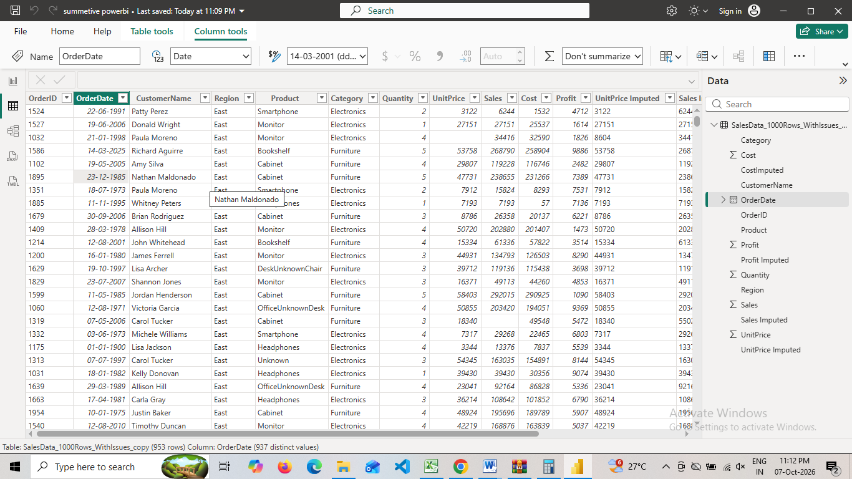

Q2: Visualizations and Insights
a) Create a Pie Chart showing order distribution across different regions.
b) Create a Column Chart to display the top 5 trending products based on the number of times each product was ordered.
c) Create a Line Chart to show the profit trend over time.
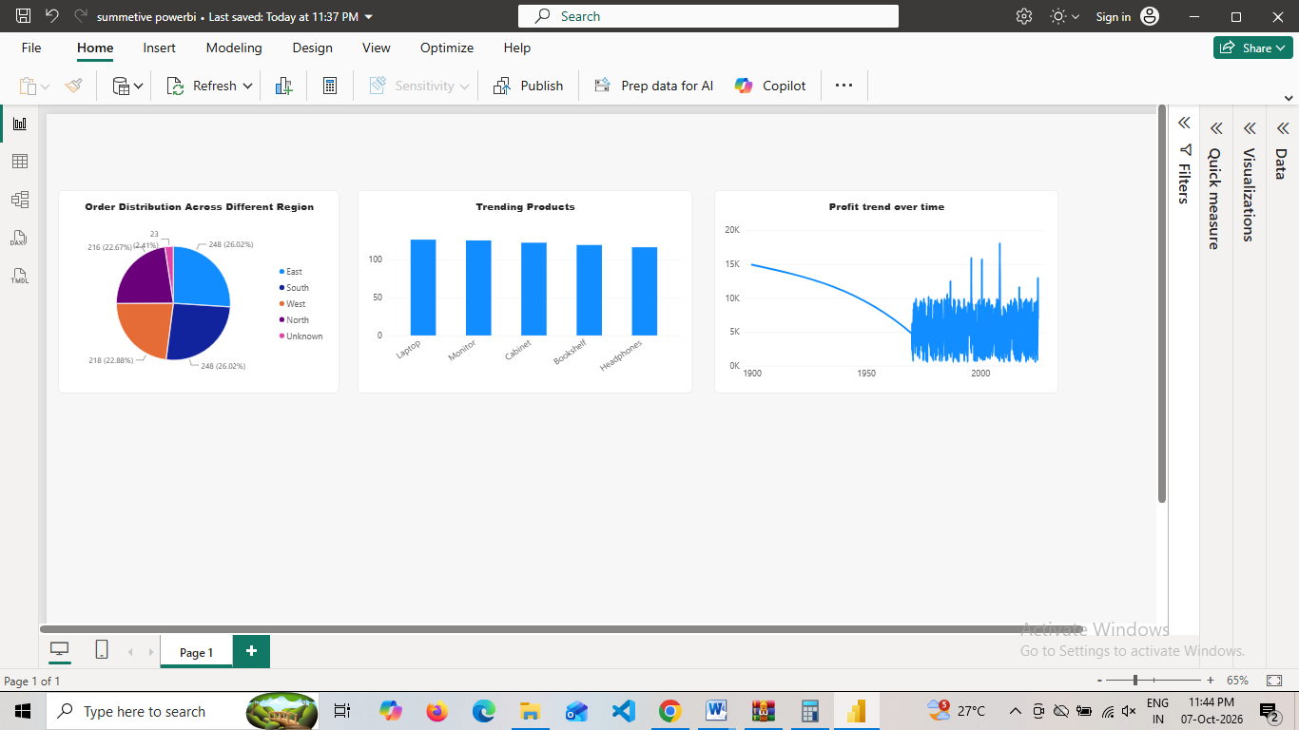

Q3: DAX Calculations
- Create a Calculated Table named EastRegionOrders that filters and displays only the orders from the East region
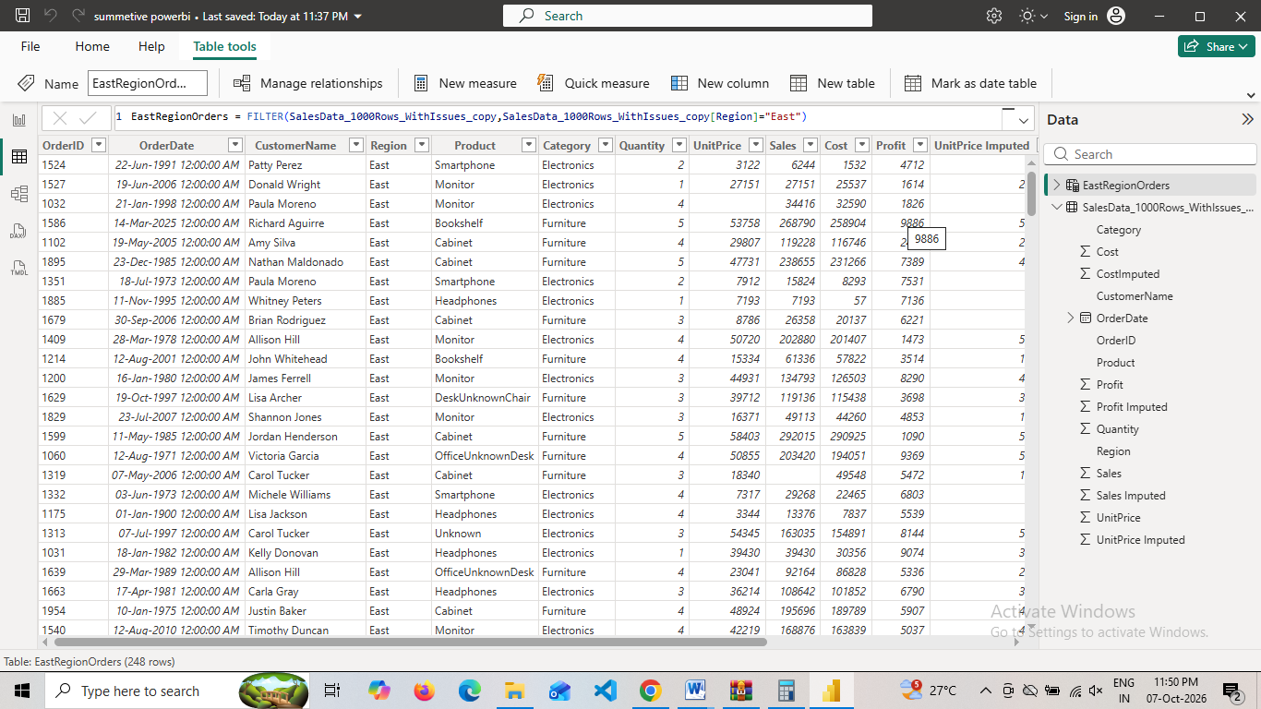
- Create a Calculated Column to compute the difference between
the Profit and Cost columns. Name it ProfitCostDifference
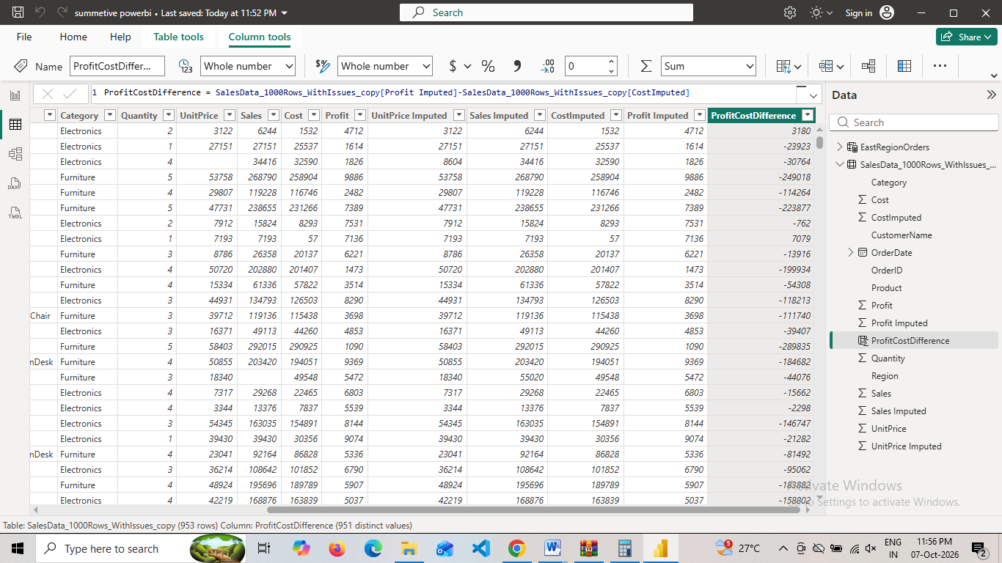
- Create a Calculated Measure to find the total profit earned. Name it TotalProfit
- 